**Software Requirements and Design Document**

**For**

**Group <10>**

Version 1.0

**Authors**:

Philip Sablan

Aditi Anandjiwala

Jacob Holleman

Josiah Walters

Krenn Intharaksa

# Overview (5 points)

JukeBoxd is a website that allows users to create accounts and rate music albums, singles, or artists. Users will be able to rate these with a “star” system (such as 3 stars out of 5). Users will be able to add personal comments or reviews on music that they have rated. JukeBoxd will grab most of its music data, specifically what albums and artists are available to rate, from Spotify’s artist and music lists. Users will be able to be linked directly to the spotify pages of music they search for on Jukeboxd. Additionally, there is a blog section where users can write and read long-form posts from other users about music.

# Functional Requirements (10 points)

For the requirements, I will list whether we met them or did not. Some of the requirements were either difficult, time-consuming, or outside our scope of expertise and thus were unable to be met at the time of the last increment. For requirements that were shaved off due to bloat or functional reasons, will be denoted Not Implemented.

1.) Users shall be able to create a unique account with username and password (Met)

2.) Users shall be able to log in to their already created accounts with correct username and password entry (Met)

3.) Users shall be able to search for music to rate on the site (Met)

4.) Users shall be able to rate and review music and have these ratings and reviews visible on their account pages (Partially Met)

5.) Users shall be able to view the ratings of other users on their account pages (Not Met)

6.) Users shall be able to search for other users in order to view their ratings (Not Met)

7.) Users shall be able to see average ratings and others’ reviews on music that they have searched for on the site (Not Met)

8.) Users shall be able to provide an additional overall “like/dislike” denomination supplementing their rating and review (Not Implemented)

9.) Users shall be able to make their account private so as to limit who can view their ratings and reviews (Not Implemented)

10.) Users shall be able to discuss music, artists, and other related topics on user forums(Met) (This is a good feature to add for flavor and usability but not 100% necessary for site function)

11.) Users shall be provided with a link to music they are reviewing/searching for that takes allows them to play the album/track on a streaming service such as spotify (Met)

12.) Users shall be able to vote on other users’ forum posts and ratings (up/downvote) (Met)

13.) Users shall be able to see their accumulated upvotes/downvotes ie karma system (Not Met)

14.) Users shall be able to specify which artist they mean to search for in the case of two artists with the same/similar name (Not Implemented)

15.) Jukeboxd will allow users to search for music by artist or by album (Current progress is only searching by artist is consistent) (Not Implemented)

# Non-functional Requirements (10 points)

1.) Users’ account and password privacy will be safe from others (Met)

2.) User reviews may not include hyperlinks to domains that are not JukeBoxd or a music streaming service (Met)

3.) During times of normal site traffic, queries to site will be consistent and quick (Met)

4.) JukeBoxd should always be available to users (Not Implemented)

5.) JukeBoxd UI should be intuitive for new users to understand and use (Met)

6.) Account authentication must be in place such that users will only be able to create or modify reviews/ratings corresponding to their signed in account. (Partially Met)

7.) Code and other relevant documentation shall be neat and appropriately sectioned, such that other group members may easily understand all parts of the project (Met)

8.) Forums/reviews shall be clean of harmful speech, hate, etc (Met... For now)

9.) The search function shall return a clean and concise list of albums in the form of uniform “cards” (Met)

# Use Case Diagram (10 points)

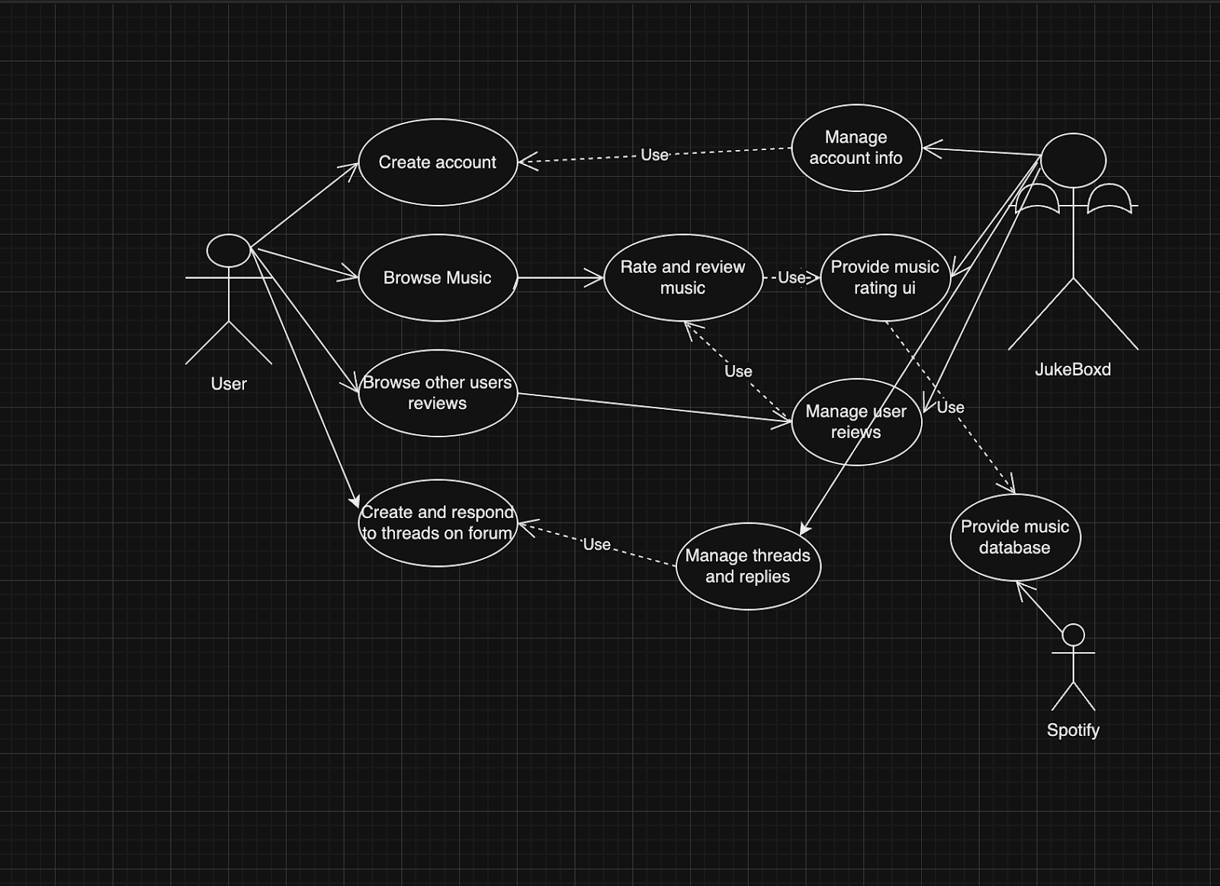Creating account: Account details must be stored in a database by Jukeboxd in order to allow for secure login and unique accounts. These details are to be stored and referenced on a user’s attempted login.

Browsing music: User will query a search into the search bar and will be shown related music. The music will be taken from the spotify api. This includes all of the artists albums and singles as well as all versions as shown by spotify. Additionally, links to these albums and singles on spotify are available on the review page for them, allowing for easy listening.

Rating and reviewing music: Upon receiving search results users shall be able to rate and review the music. These reviews must be managed and stored by Jukeboxd. Additionally, the ui elements necessary to rate the music will be provided by Jukeboxd in a visually concise manner.

Browsing other user reviews: Users will be able to view the ratings of other users either through the music search function or from other users’ account page. These reviews will be stored and managed by Jukeboxd. (This was ultimately not implemented in time for the last increment).

Create and respond to threads: Users will be able to navigate to the Jukeboxd forums where they will be able to create threads/new forum posts and respond to other users. These forum posts and replies will be stored and managed by Jukeboxd.

# Class Diagram and/or Sequence Diagrams (15 points)

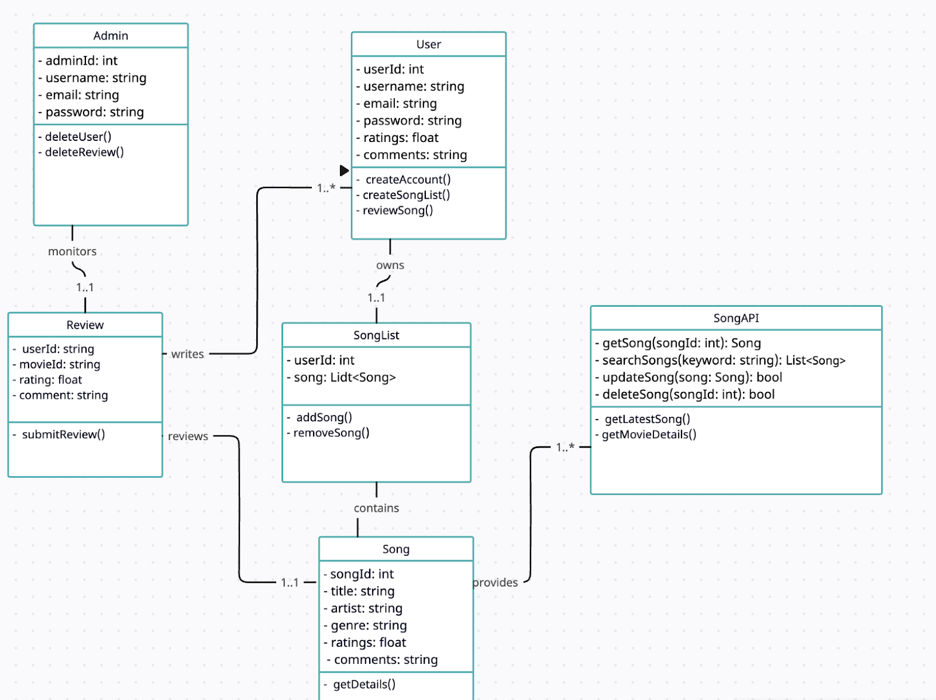

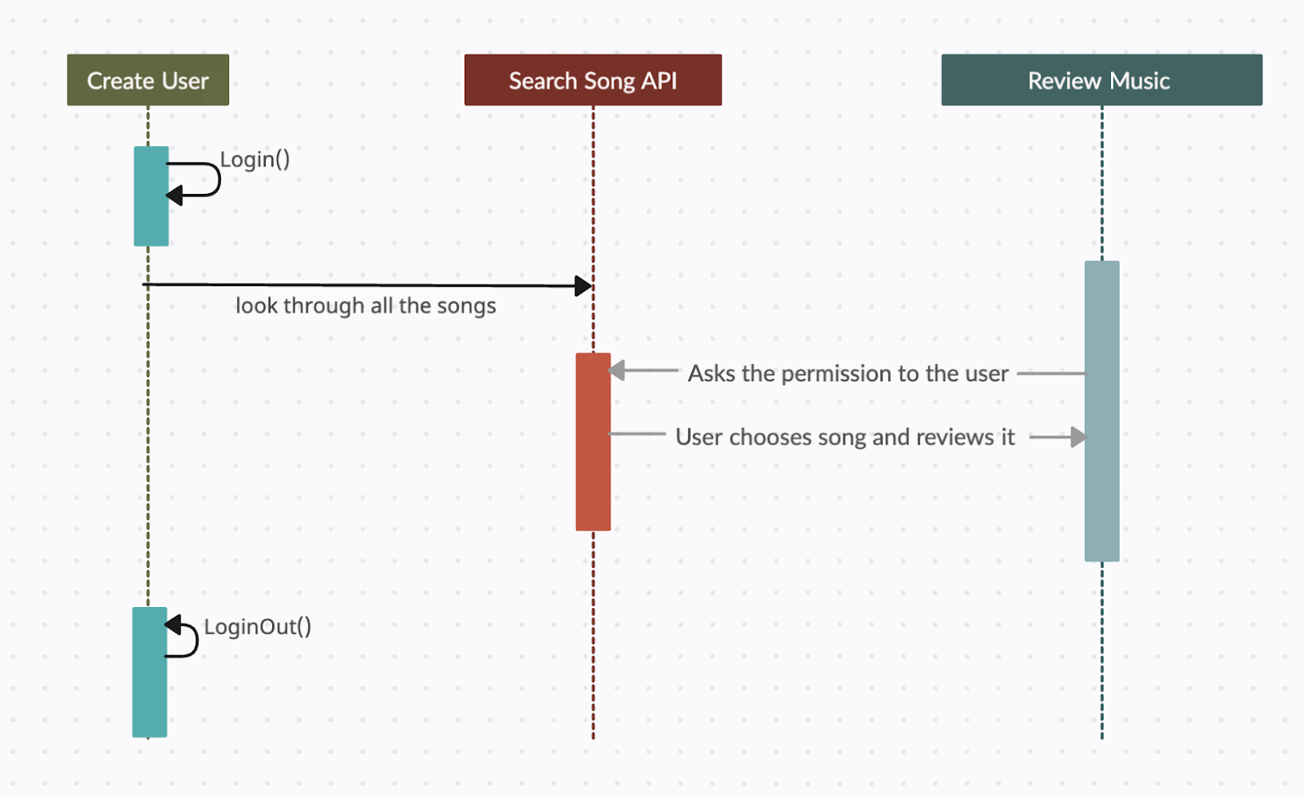

# Operating Environment (5 points)

We are using React version 18.2 to run the website, Bootstrap version 5.3.2, and Adobe CSS tools 4.3.3. Website has been run on Macbook and Windows laptops. Currently using VisualCode in conjunction with GitHub to store and work on code.

# Assumptions and Dependencies (5 points)

The project is reliant on a database of music, specifically music that is hosted on spotify. As is currently planned, the only music that will be available to rate will be what is posted on spotify. Thus, changes to this database will affect what music is available and access to it is important for the development of JukeBoxd. As of current JukeBoxd is only available through local hosting.